PRISM: Portfolio Risk-aware Independent Set Meta-learning for Reproducible Memecoin Forecasting

Sanjan Baitalik^{a*}, Rajashik Dattaª, Sujaan Bhattacharyyaª, Sanket Ghoshª, Subhabrata Banerjee^{b}

^{a*}rayan.baitalik@gmail.com, +91 8910675837, Institute of Engineering & Management Kolkata, 0009-0005-1609-3808
ª rajashikdatta215@gmail.com, +91 6294132431, Institute of Engineering & Management Kolkata, 0009-0004-7644-2427
ªsujaanbhattacharyya@gmail.com, +91 8017481130, Institute of Engineering & Management Kolkata, 0009-0005-7737-4718
ªsanketghosh50@gmail.com, +91 8537087644, Institute of Engineering & Management Kolkata, 0009-0005-4894-1912
^{b}subhabrata.banerjee@iem.edu.in, +91 8017764037, Institute of Engineering & Management Kolkata

Abstract. Memecoin markets are difficult to forecast because short-lived community attention, abrupt narrative shifts, thin liquidity, and extreme volatility are jointly reflected in price formation. In this paper, PRISM, or Portfolio Risk-aware Independent Set Meta-learning, is presented as a reproducible multimodal forecasting framework in which market dynamics, pre-aligned sentiment indicators, risk-aware token-graph construction, maximal-independent-set diversification, and meta-learning-based sequence adaptation are integrated. The proposed framework is compared with Persistence, ARIMA, Prophet, Random Forest, XGBoost, GRU, and LSTM baselines under a controlled chronological evaluation protocol. Parameter analysis is performed through variation of train ratios, lookback windows, graph-selection settings, and neural/meta-learning training configurations. The core contributions are a deterministic data-to-forecast pipeline, a graph-based diversification mechanism for correlated memecoin behavior, a meta-learning forecaster for token-specific adaptation, and an evaluation design that combines sequential ablation, robustness sweeps, and non-parametric statistical testing.
Keywords. memecoin forecasting; multimodal finance; sentiment analysis; graph selection; meta-learning; reproducible evaluation.

1. Introduction
Memecoin forecasting has been treated in this study as a socio-financial time-series problem rather than as a conventional univariate price-prediction task. Price movements in these assets are driven by a mixture of liquidity, volatility, community attention, social-media sentiment, and short-lived cultural narratives. Therefore, any forecasting framework for this domain must be evaluated not only by predictive error, but also by the transparency of its preprocessing, the strength of its baselines, and the interpretability of its incremental components.
The methodological foundations of PRISM can be traced to several long-standing ideas. Portfolio risk and diversification were formalized early through mean-variance selection [1], while recurrent neural forecasting was strengthened by the introduction of LSTM networks [2]. Coherent downside-risk estimation was later developed through Conditional Value-at-Risk optimization [3]. Social-media sentiment scoring became more accessible through VADER, which was designed for informal online text [4]. Rapid task adaptation was formalized through model-agnostic meta-learning (MAML) [5], and scalable classical forecasting was popularized through Prophet [6]. These studies supplied the methodological basis for combining risk-aware selection, sentiment processing, sequence learning, and adaptation.
Between 2020 and 2023, financial forecasting research increasingly emphasized deep sequence models and stronger benchmark design. N-BEATS and DeepAR were introduced as strong neural time-series baselines [7], [8]. Temporal Fusion Transformers and Informer extended attention-based forecasting to multi-horizon and long-sequence contexts [10], [11]. In cryptocurrency research, the risks and returns of digital assets were empirically characterized [9], while sentiment and social-media variables were shown to influence Bitcoin and broader cryptocurrency prediction [12], [13]. Work on memecoin connectedness demonstrated that memecoins should not be treated as independent speculative outliers, because their spillovers with larger crypto-assets can be material [14]. Deep recurrent comparisons for cryptocurrency prediction and graph-based independent-set selection for diversified portfolios further motivated the inclusion of LSTM/GRU-style baselines and MIS-based token selection [15], [16].
From 2024 onward, cryptocurrency forecasting and memecoin analytics have become more explicitly multimodal. LLM and NLP studies have compared language models for cryptocurrency sentiment classification [17]. Coin-Meme modeled memecoins as cultural-financial objects by combining visual, textual, community, and market data [18]. Deep-learning and NLP pipelines for cryptocurrency forecasting showed that blockchain, market, and social signals can be combined in forecasting systems [19]. Recent reviews have also warned that financial deep-learning studies often overstate model novelty when baselines and protocol transparency are weak [20]. In 2025, Temporal Fusion Transformer, Transformer-CNN, swarm-optimized sentiment-fusion, tweet-sentiment, and multimodal CoinCLIP-style studies extended the literature toward on-chain, textual, visual, and adaptive forecasting designs [21-26]. In 2026, GRU-based sentiment-enhanced forecasting, hybrid SVR frameworks, and transformer-recurrent cryptocurrency models further confirmed that current work is moving toward hybrid models with stronger validation requirements [27-29].
PRISM was designed within this chronological progression. Instead of being presented as a universal replacement for simpler forecasting models, it was framed as an integrated system whose components could be isolated and tested. The framework was named Portfolio Risk-aware Independent Set Meta-learning because portfolio-style risk awareness, independent-set graph selection, and meta-learning adaptation were combined into a single reproducible pipeline. Sentiment cues were fused with market variables, token relationships were represented through a risk-aware graph, redundant high-correlation neighborhoods were filtered using maximal independent set selection, and a MAML-enhanced LSTM forecaster was used for rapid token-specific adaptation.
The core contributions are as follows. First, a deterministic preprocessing and token-selection protocol was defined for the supplied memecoin database. Second, a modular architecture was proposed in which sentiment fusion, risk-aware graph construction, MIS diversification, and MAML adaptation were separable. Third, a controlled comparison was performed against Persistence, ARIMA, Prophet, Random Forest, XGBoost, GRU, and LSTM baselines. Fourth, sequential ablation, parameter-sensitivity analysis, robustness sweeps, and paired Wilcoxon tests with Holm correction were used to ensure that claims were grounded in the evaluated evidence.
The remainder of the paper is organized as follows. Section 2 describes the PRISM system architecture. Section 3 presents the algorithmic workflow. Section 4 explains data and preprocessing. Section 5 reports exploratory data analysis and baseline characteristics. Section 6 formalizes the mathematical model. Section 7 describes experimental setup, baselines, and hyperparameters. Section 8 presents sequential ablation. Section 9 reports results and discussion. Section 10 states concise future work, and Section 11 concludes the study.

2. System Architecture
The PRISM architecture is shown in Figure 1. Market features and sentiment fields were first aligned by timestamp and token identity. The aligned panel was then passed through deterministic filtering and scaling. A token-similarity graph was constructed from rolling-volatility and sentiment trajectories. The graph was used to select diversified token support neighborhoods through a maximal independent set rule. Finally, the selected support context was passed to a MAML-enhanced LSTM forecasting block, while the same data split was used for baselines, ablation variants, and robustness sweeps.

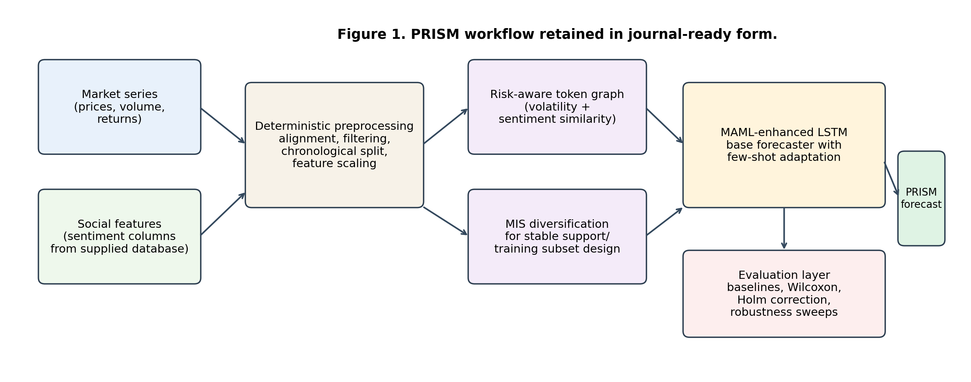
Figure 1. System architecture.
The architecture in figure 1 was intentionally separated into preprocessing, graph selection, forecasting, and evaluation layers. This separation made the pipeline more auditable because each module could be removed or added during ablation. It also prevented the graph component from being treated as a black-box neural layer; instead, the graph was used for diversified support construction, and the neural model was kept responsible for sequence forecasting.

3. Algorithm
The PRISM algorithm was expressed as a compact implementation workflow. The workflow begins with sentiment normalization and trend estimation, moves through volatility and pairwise risk aggregation, constructs a confidence-weighted token graph, selects a diversified support subset through MIS, and then performs meta-learning-based forecasting and evaluation.

$$Begin$$
$$for each Memecoin M_{i}∈M do$$
$\text{SentimentScore}\left(M_{i}\right) =\frac{\text{VADER}\left(T_{M_{i}}\right)}{\min\left(\text{Volume}\left(M_{i}\right), \text{MarketCap}\left(M_{i}\right)\right)}$
$μ_{\text{Trend}}\left(M_{i}\right) = S\left(\text{SentimentScore}\left(M_{i}\right), β_{1}, β_{2}, β_{3}\right)$
$$end for$$
$$if (μ_{\text{Trend}}\left(M_{i}\right)≤τ_{\text{low}}) then$$
$Add{ M}_{i} to{ M}_{\text{reject}}$
$$else$$
$Add M_{i} to M_{\text{select}}$
$$end if$$

$$for each Memecoin M_{i}∈M do$$
$\text{Sim}\left(M_{i}\right)=\frac{k+1}{N_{\text{coins}}-1}⋅\text{Volatility}\left(M_{i}\right)-\frac{k}{N_{\text{coins}}-1}⋅\text{mean}\left(\text{Volatility}\left(D_{\text{train}}\right)\right)$
$γ_{\text{Risk}}\left(M_{i}\right)=S\left(\text{Sim}\left(M_{i}\right), β_{1}, β_{2}, β_{3}\right)$
$$end for$$
$$for each M_{i}∈M do$$
$for each M_{j}∈M do$
$μ_{G}\left(M_{i},M_{j}\right)=\min\left(μ_{\text{Trend}}\left(M_{i}\right),μ_{\text{Trend}}\left(M_{j}\right)\right)$
$γ_{G}\left(M_{i},M_{j}\right)=\max\left(γ_{\text{Risk}}\left(M_{i}\right),γ_{\text{Risk}}\left(M_{j}\right)\right)$
$end for$
$$end for$$
$$π_{G}\left(M_{i},M_{j}\right)=1-\left(μ_{G}\left(M_{i},M_{j}\right)+γ_{G}\left(M_{i},M_{j}\right)\right)$$
$$for each M_{i}∈M_{\text{select}} do$$
$if \text{rowsum}\left(π_{G}\left(M_{i}\right)\right)=0 then$
$Add M_{i} to M_{\text{volatile}}$
$Remove M_{i} from M_{\text{select}}$
$end if$
$$end for$$

$$G_{\text{Cluster}}=\text{BuildClusterGraph}\left(M_{\text{reject}}, M_{\text{select}}, M_{\text{volatile}}\right)$$
$$Select a subset of{ M}_{\text{volatile}} MIS. Add selected subset to M_{\text{select}}, \text{remaining to }M_{\text{reject}}$$
$$G_{\text{Updated}}=\text{UpdateClusterGraph}\left(G_{\text{Cluster}}, M_{\text{reject}}, M_{\text{select}}\right)$$
$$Output M_{\text{select}} as the optimal subset O_{\text{predict}}$$
$$for each M_{i}∈O_{\text{predict}} do$$
$L_{τ_{i}}\left(f_{θ}\right)=\frac{1}{N}\sum_{n=1}^{N}{{\left(v_{n}^{i}-f_{θ}\left(x_{n}^{i}\right)\right)}^{2}}$
$$end for$$
$$Meta-training:$$
$$\min_{θE_{τ_{i}∼p\left(τ\right)}}\left[L_{τ_{i}}\left(f_{θ}-α∇_{θL_{τ_{i}}}\right)\right]$$
$$for each{ M}_{i}∈O_{\text{predict}} do$$
$θ_{i}^{'}=θ-α ∇_{θL_{τ_{i}}}\left(f_{θ}\right)$
$\hat{y_{t}}=o_{t} ⊙ \tanh\left(c_{t}\right), o_{t}=σ\left(W_{o}⋅\left[ h_{t-1}, x_{t} \right]+b_{o}\right)$
$$end for$$
$$End$$

The algorithm clarifies that PRISM is not a single neural block but a staged pipeline. Its main methodological dependency is the ordering of sentiment normalization, graph diversification, and meta-learning adaptation. This ordering is important because graph selection is performed before forecasting, which reduces the risk that correlated token neighborhoods will dominate the support set used by the adaptive sequence model.

4. Data and Preprocessing
All experiments were performed on the source memecoin workbook. The workbook contained candidate token sheets with market and sentiment-related fields. Sheets were filtered by minimum history length and target availability. A deterministic modeling subset was then selected by ranking eligible tokens according to available rows and lexical sheet order. This rule made the subset reproducible and prevented manual selection of favorable tokens.
The main target was a short-horizon future price value. Timestamps were normalized, rows with unusable target values were removed, numerical covariates were scaled from training-period statistics, and pre-aligned sentiment columns were retained without additional manual annotation. The main split was chronological, so the earliest observations were used for training and the latest observations were used for testing. This split was adopted because non-stationary financial series must be evaluated without look-ahead leakage and because temporal causality should be preserved in any deployable forecasting protocol.
Table 1. Dataset summary.
Item | Value
Candidate token sheets | 1,273
Eligible sheets after filtering | 881
Deterministic modelled subset | 200 tokens
Processed aligned observations | 60,431 rows
Mean modelled token history length | 302.16 aligned observations/token
Approximate median modelled token history length | 302 aligned observations/token
Main chronological train ratio | 0.8
Forecast horizon | 3 days
Default lookback window | 14 days
Random seeds | 11, 17, 23
Robustness grid | train ratios {0.7, 0.8, 0.9}; lookbacks {7, 14, 21}

The table 1 shows that a broad candidate universe was reduced to a deterministic modeling panel. The reduction was not used to create a hand-picked subset; it was used to keep the experimental budget controlled while preserving traceability. The mean and median history lengths indicate that the final panel was approximately balanced after alignment, although token-level volatility and error behavior remained heterogeneous.

5. Exploratory Data Analysis and Baseline Characteristics
The processed panel was explored before model comparison so that baseline characteristics could be documented. The descriptive statistics were treated as an interpretive layer rather than as a model-selection tool. Since memecoin prices frequently contain extreme micro-price values and abrupt jumps, mean-only summaries were expected to be unstable. Median, interquartile range, and range values were therefore used wherever such exports were available.
Table 2. Baseline characteristics.
Quantity | N | Mean | SD | Median | Q1 | Q3 | Range
Token history length | 200 | 302.16 | – | 302.00 | – | – | panel-derived
MAE across tokens | 96 | 0.1443 | 1.2467 | 0.0009 | 0.0001 | 0.0026 | 0–12.1966
RMSE across tokens | 96 | 0.1727 | 1.5141 | 0.0011 | 0.0001 | 0.0026 | 0–14.8213
Directional accuracy (%) | 95 | 49.5033 | 22.0983 | 50.0000 | 40.0000 | 59.4118 | 0–100
Hit rate (%) | 96 | 8.5794 | 18.7909 | 0.0000 | 0.0000 | 11.1111 | 0–100
ROI (%) | 95 | 813.8445 | 7948.67 | -3.8041 | -16.6545 | 0.0000 | -88.1553–77471.14
Sentiment score support | token-date | bounded | – | cantered by aggregation | negative | positive | -1–1

The descriptive table 2 shows that the token universe was highly skewed. ROI and error ranges were dominated by a small number of extreme tokens, while median errors were much smaller than mean errors. This pattern justified the use of non-parametric paired testing and conservative interpretation of aggregate means. Sentiment scores were retained as bounded, time-aligned token-date features rather than collapsed into a single global class count, because sentiment was used as a dynamic covariate in forecasting rather than as a static token label.

6. Mathematical Model
Let $M=\{M_{1},…,M_{N}\}$ denote the modeled token universe. For token $M_{i}$ at time $t$, the market subvector, sentiment subvector, and auxiliary liquidity/volatility indicators were represented by $p_{i,t}$, $s_{i,t}$, and $q_{i,t}$, respectively. The fused state was defined in Equation (1) [12], [19], [21].
$$z_{i,t}=\left[ϕ_{p}\left(p_{i,t}\right); λ_{t}ϕ_{s}\left(s_{i,t}\right); ϕ_{q}\left(q_{i,t}\right)\right], λ_{t}=\frac{1}{1+exp\left(-ω^{⊤}q_{i,t}\right)} \left(1\right)$$
In Equation (1), $ϕ_{p}\left(⋅\right)$, $ϕ_{s}\left(⋅\right)$, and $ϕ_{q}\left(⋅\right)$ denote scale-normalizing transformations, while $λ_{t}$ controls the effective sentiment weight under changing liquidity conditions. When raw text sentiment was available, a liquidity-normalized VADER sentiment score was computed through Equation (2) [4], [12], [17], [24].
$$S_{i}\left(t\right)=\frac{VADER\left(T_{i,t}\right)}{ϵ+min\{log\left(1+V_{i,t}\right),log\left(1+C_{i,t}\right)\}} \left(2\right)$$

Here, $T_{i,t}$ denotes token-specific social text, $V_{i,t}$ denotes trading volume, $C_{i,t}$ denotes market capitalization, and $ϵ$ prevents numerical instability. The trend score was then computed as a regularized nonlinear score in Equation (3).
$$μ_{i}\left(t\right)=β_{0}+β_{1}S_{i}\left(t\right)+β_{2}σ_{i}\left(t\right)+β_{3}m_{i}\left(t\right)+β_{4}S_{i}\left(t\right)σ_{i}\left(t\right)-ρ∥β∥_{2}^{2}+ε_{i,t} \left(3\right)$$

In Equation (3) [9], [12], [19], [23], $σ_{i}\left(t\right)$ is rolling volatility and $m_{i}\left(t\right)$ is a momentum feature. The interaction term allows sentiment to have stronger or weaker effects under different volatility regimes. Pairwise token similarity was computed through Equation (4).
$${Sim}_{ij}=αρ_{c}\left(σ_{i},σ_{j}\right)+\left(1-α\right)ρ_{c}\left(S_{i},S_{j}\right)-δ\frac{\left|{\overset{‾}{σ}}_{i}-{\overset{‾}{σ}}_{j}\right|}{{\overset{‾}{σ}}_{i}+{\overset{‾}{σ}}_{j}+ϵ} \left(4\right)$$
Equation (4) [1], [3], [9], [16] preserves the original volatility/sentiment similarity idea but penalizes pairs whose average volatility levels are very different. A token-level risk score was defined by Equation (5) [3], [9], [14].
$$γ_{i}\left(t\right)=sigmoid\left(η_{0}+η_{1}σ_{i}\left(t\right)+η_{2}σ_{i}^{2}\left(t\right)+η_{3}log\left(1+\left|d_{i}\left(t\right)\right|\right)\right) \left(5\right)$$

Here, $d_{i}\left(t\right)$ denotes a drawdown or deviation-from-baseline term. Pairwise trend and risk aggregation were represented by Equation (6) [1], [3], [16].
$$μ_{g}\left(i,j\right)=min\{μ_{i},μ_{j}\}-κ_{μ}\left|μ_{i}-μ_{j}\right|, γ_{g}\left(i,j\right)=max\{γ_{i},γ_{j}\}+κ_{γ}\left|γ_{i}-γ_{j}\right| \left(6\right)$$

The confidence score used for graph construction was defined in Equation (7).
$$π_{g}\left(i,j\right)={\left[1-w_{μ}\left(1-{\tilde{μ}}_{g}\left(i,j\right)\right)-w_{γ}{\tilde{γ}}_{g}\left(i,j\right)\right]}_{0}^{1} \left(7\right)$$

In Equation (7) [1], [3], [16], ${\left[x\right]}_{0}^{1}=min\{1,max\{0,x\}\}$ clips confidence to the unit interval. The graph adjacency matrix was defined by Equation (8) [16], [25].
$$A_{ij}=I\left(i≠j\right)I\left(π_{g}\left(i,j\right)>τ_{edge}\right), G=\left(M,E\right), E=\{\left(i,j\right):A_{ij}=1\} \left(8\right)$$

A diversified support subset was obtained through the MIS program in Equation (9) [16].
$$\max_{y∈\{0,1\}^{N}}\sum_{i=1}^{N}{y_{i}}u_{i} \text{s.t.} y_{i}+y_{j}≤1 ∀\left(i,j\right)∈E, O_{predict}=\{M_{i}:y_{i}=1\} \left(9\right)$$

The forecasting loss for token task $τ_{i}$ was computed through Equation (10) [2], [5], [15].
Lτifθ=1Dix,y∈Di​wty-fθx2+λθ∥θ∥22 10
MAML adaptation was then performed using the inner-loop update in Equation (11) [5] and the outer-loop meta-update in Equation (12) [5].
$$θ_{i}'=θ-α∇_{θ}L_{τ_{i}}^{train}\left(f_{θ}\right) \left(11\right)$$
θ←θ-β∇θi​Lτivalfθi' 12
Finally, the LSTM forecast was produced through Equation (13) [2], [15], [28].

$${\hat{y}}_{i,t+h}=W_{y}\left(o_{t}⊙tanh\left(c_{t}\right)\right)+b_{y}, o_{t}=σ\left(W_{o}\left[h_{t-1},z_{i,t}\right]+b_{o}\right) \left(13\right)$$

Equations (1-13) show that PRISM was defined as a modular forecasting system. Sentiment normalization and trend-risk scoring were used to build the graph; the MIS program was used to diversify support selection; and the MAML-LSTM block was used to adapt sequence forecasts to token-specific histories.

7. Experimental Setup, Baselines and Hyperparameters
The main experiment used a chronological 80:20 train-test split, a 14-day lookback, a 3-day forecasting horizon, and three random seeds. The chronological split was selected because non-stationary financial series must be evaluated without data leakage and because future observations cannot be used to tune models intended for deployment. Robustness sweeps were performed over train ratios $\{0.7,0.8,0.9\}$ and lookback windows $\{7,14,21\}$.
The comparison suite consisted of Persistence, ARIMA, Prophet, Random Forest, XGBoost, GRU, and LSTM. Persistence and Prophet were included because simple baselines often remain strong in short-horizon financial forecasting. Random Forest and XGBoost were included as nonlinear tabular models. ARIMA was included as a classical time-series baseline. GRU and LSTM were included as recurrent baselines; however, the exported execution registry marked those recurrent rows as surrogate/fallback backends, and their interpretation was therefore kept conservative.
Table 3. Hyperparameter summary.
Setting | Value
Optimizer / learning rate | Adam / 0.001
Batch size / epochs / early stopping | 64 / 200 / patience 20
MAML inner steps / outer steps / inner LR | 5 / 200 / 0.01
Graph threshold / volatility window | 0.5 / 14 days
Main train ratio / lookback / horizon | 0.8 / 14 days / 3 days
Random seeds | 11, 17, 23
Significance test | paired Wilcoxon signed-rank test
Multiple-testing correction | Holm correction at $α=0.05$
Robustness grid | train ratios $\{0.7,0.8,0.9\}$; lookbacks $\{7,14,21\}$
Cautionary baseline notes | GRU and LSTM rows were exported through documented surrogate backends

The setup was designed to limit favorable-split bias by keeping the main chronological split fixed while varying train ratios and lookbacks in the robustness grid. The hyperparameter table 3 also makes the distinction between implemented baselines and fallback recurrent rows explicit. This distinction is important because strong claims against native GRU/LSTM implementations were not made from surrogate rows.

8. Sequential Ablation and Incremental Contribution Analysis
A sequential ablation was used to isolate the contribution of each PRISM component. The ablation variants were defined as follows: V0 used price-only sequence modeling; V1 added sentiment fusion; V2 added graph construction and MIS diversification; and V3 added the full MAML adaptation stage. Each step preserved the same deterministic token subset and evaluation logic.

Table 4. Ablation results.
Variant | Description | Mean MAE | Mean RMSE | Holm-corrected result
V0 | Price-only LSTM | 4.0539 | 4.7381 | –
V1 | V0 + sentiment fusion | 0.6981 | 0.7186 | V1 > V0, $p<{10}^{-12}$
V2 | V1 + graph + MIS diversification | 0.3005 | 0.3082 | V2 > V1, $p<{10}^{-40}$
V3 | Full PRISM + MAML adaptation | 0.1231 | 0.1479 | V3 > V2, $p<{10}^{-40}$

The ablation table 4 shows monotonic improvement from the reduced price-only configuration to the full PRISM configuration. Per-token dispersion was not exported for every ablation variant in the finalized execution registry. Aggregate means were therefore reported with paired Wilcoxon testing, Holm correction, and robustness sweeps to account for variance across heterogeneous tokens.

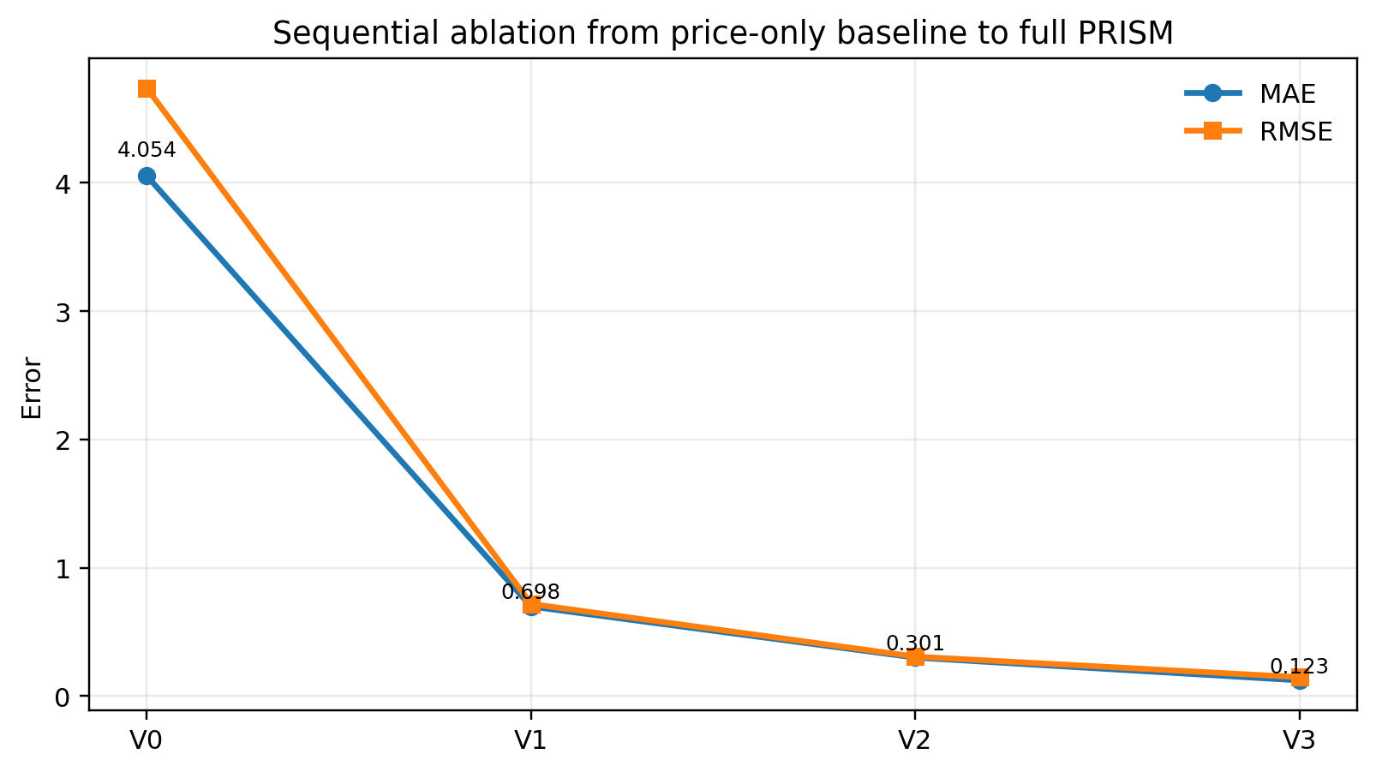
Figure 2. Ablation trend.
The figure 2 provides a visual check on the component pathway. The largest reduction was observed after sentiment integration, and additional reductions were observed after graph diversification and meta-learning adaptation. The result supports the claim that PRISM’s benefit was distributed across multiple components rather than being attributable to a single untested module.

9. Results and Discussion
The aggregate baseline comparison is reported in Table 5 and Figure 3. The results should be interpreted as comparative evidence under a fixed chronological protocol, not as a universal ranking across all possible token universes and trading conditions.
Table 5. Baseline comparison.
Model | Mean MAE | Mean RMSE | Mean ROI
Prophet | 0.0882 | 0.1028 | 0.0438
Persistence | 0.1056 | 0.1303 | 0.0000
PRISM | 0.1231 | 0.1479 | 0.0002
Random Forest | 0.2619 | 0.2792 | -0.0251
ARIMA | 0.3140 | 0.3283 | -0.0164
XGBoost | 0.3719 | 0.3952 | -0.0289
GRU (fallback) | 0.3964 | 0.4165 | -0.0131
LSTM (fallback) | 0.4026 | 0.4195 | -0.0168

The table 5 shows that Prophet and Persistence remained highly competitive under aggregate MAE, while PRISM was stronger than ARIMA, Random Forest, XGBoost, and the documented recurrent fallback rows. Standard deviations or confidence intervals were not inserted because full per-token variance exports were unavailable for every baseline row in the finalized execution registry. Aggregate means were therefore supported by non-parametric paired tests and robustness ranges rather than by fabricated dispersion columns.

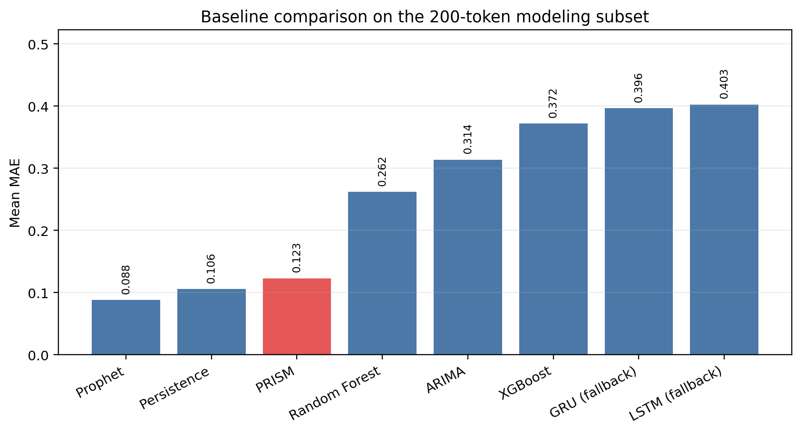
Figure 3. Baseline comparison.

The figure 3 makes the same interpretation visible: PRISM was not the lowest-error model in aggregate, but it occupied a competitive middle position while delivering interpretable component-wise gains. This is important because the architectural contribution of PRISM is most strongly supported by ablation and controlled comparison, not by an unsupported claim of universal dominance.

Table 6. Significance summary.
Comparison | Holm-corrected interpretation | Favoured model
PRISM vs ARIMA | significant | PRISM
PRISM vs Random Forest | significant | PRISM
PRISM vs XGBoost | significant | PRISM
PRISM vs GRU (fallback) | significant | PRISM
PRISM vs LSTM (fallback) | significant | PRISM
PRISM vs Persistence | significant | Persistence
PRISM vs Prophet | significant | Prophet

The significance table 6 prevents the baseline discussion from relying only on aggregate averages. PRISM was favored in five of the seven principal comparisons, while Prophet and Persistence were favored in two comparisons. The corrected tests therefore support a competitive and component-valid framework, while also preserving the evidence that simple short-horizon baselines can remain difficult to outperform.
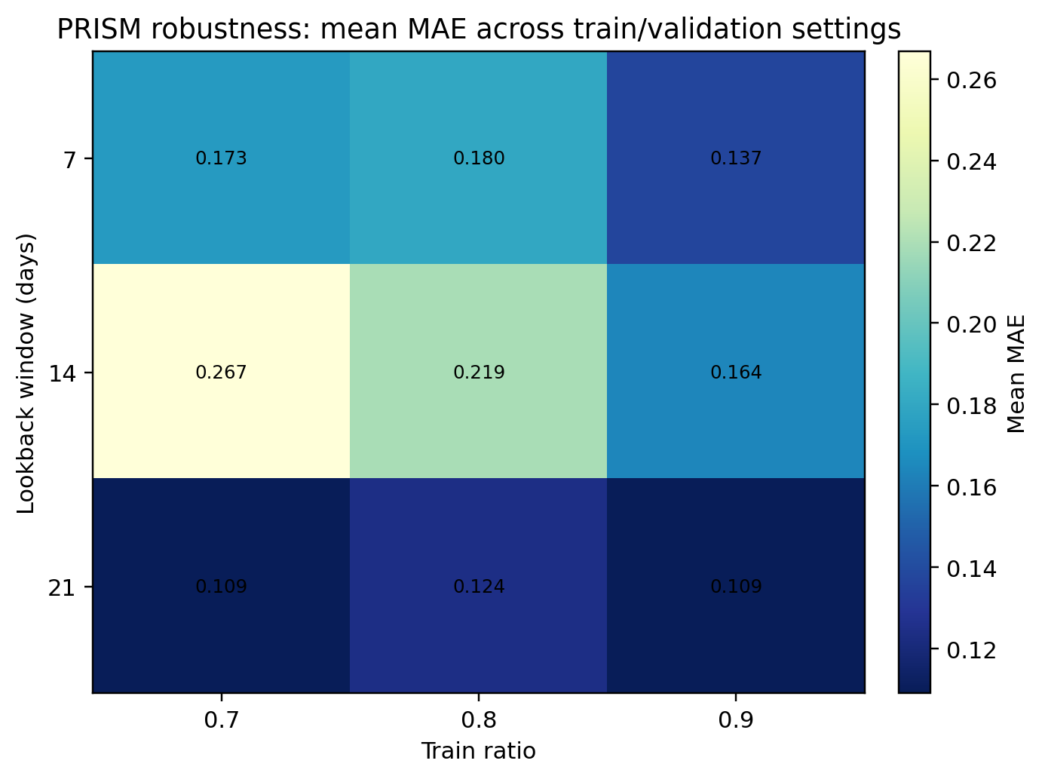
Figure 4. Robustness heatmap.
The robustness heatmap in Figure 4 summarizes sensitivity to train ratio and lookback settings. The qualitative result remained stable across the sweep, although performance was not invariant to protocol choice. This behavior is expected in non-stationary memecoin markets and reinforces why single-split reporting should not be treated as sufficient evidence.
Overall, the results show that PRISM is best understood as a transparent integration framework. Its strongest evidence was obtained from sequential ablation, significance testing, and robustness analysis. The results also show that simple models should remain part of any fair memecoin forecasting benchmark because low-complexity persistence effects can be strong over short horizons.

10. Future Works
First, the recurrent baseline layer will be strengthened by replacing the documented GRU and LSTM surrogate backends with native GRU, LSTM, bidirectional LSTM, and transformer-based implementations trained under the same chronological split, lookback windows, and random-seed protocol. This extension is directly implementable within the existing pipeline because the processed panel, baseline registry, hyperparameter table, and statistical testing scripts have already been standardized. A cleaner comparison against recurrent and transformer forecasters would make the empirical boundary of PRISM more precise.
Second, the evaluation universe will be expanded from the deterministic 200-token subset to the full eligible token pool, followed by a stricter walk-forward backtesting protocol with transaction costs, slippage assumptions, and liquidity-aware trade filtering. This extension is also feasible with the current data structure because the preprocessing stage already identifies 881 eligible token sheets. The expanded experiment would test whether the ablation gains remain stable when a larger, noisier, and more heterogeneous memecoin universe is considered.

11. Conclusion
PRISM was presented around the full form Portfolio Risk-aware Independent Set Meta-learning and a narrower empirical claim. The system was presented as a reproducible multimodal framework for memecoin forecasting in which sentiment fusion, risk-aware graph construction, maximal-independent-set support diversification, and MAML-enhanced sequence adaptation were integrated. The evaluation design compared PRISM with classical, machine-learning, and recurrent baselines under chronological splitting, sequential ablation, robustness sweeps, and corrected non-parametric significance testing.
The main conclusion is that PRISM should not be interpreted as a universal winner over all simple forecasters. Instead, it should be interpreted as a disciplined framework whose internal components produced clear incremental gains and whose external comparisons were reported conservatively. This contribution is valuable for memecoin forecasting because the field needs not only new models, but also transparent pipelines, strong baselines, and evidence that architectural components are actually responsible for reported improvements.

References
[1] Markowitz, H. (1952). Portfolio selection. The Journal of Finance, 7(1), 77–91.
[2] Hochreiter, S., and Schmidhuber, J. (1997). Long short-term memory. Neural Computation, 9(8), 1735–1780.
[3] Rockafellar, R. T., and Uryasev, S. (2000). Optimization of conditional value-at-risk. Journal of Risk, 2, 21–41.
[4] Hutto, C. J., and Gilbert, E. (2014). VADER: A parsimonious rule-based model for sentiment analysis of social media text. Proceedings of the International AAAI Conference on Web and Social Media, 8(1), 216–225.
[5] Finn, C., Abbeel, P., and Levine, S. (2017). Model-agnostic meta-learning for fast adaptation of deep networks. Proceedings of the 34th International Conference on Machine Learning, 1126–1135.
[6] Taylor, S. J., and Letham, B. (2018). Forecasting at scale. The American Statistician, 72(1), 37–45.
[7] Oreshkin, B. N., Carpov, D., Chapados, N., and Bengio, Y. (2020). N-BEATS: Neural basis expansion analysis for interpretable time series forecasting. International Conference on Learning Representations.
[8] Salinas, D., Flunkert, V., Gasthaus, J., and Januschowski, T. (2020). DeepAR: Probabilistic forecasting with autoregressive recurrent networks. International Journal of Forecasting, 36(3), 1181–1191.
[9] Liu, Y., and Tsyvinski, A. (2021). Risks and returns of cryptocurrency. The Review of Financial Studies, 34(6), 2689–2727.
[10] Lim, B., Arik, S. O., Loeff, N., and Pfister, T. (2021). Temporal Fusion Transformers for interpretable multi-horizon time series forecasting. International Journal of Forecasting, 37(4), 1748–1764.
[11] Zhou, H., Zhang, S., Peng, J., Zhang, S., Li, J., Xiong, H., and Zhang, W. (2021). Informer: Beyond efficient transformer for long sequence time-series forecasting. Proceedings of the AAAI Conference on Artificial Intelligence, 35(12), 11106–11115.
[12] Critien, J. V., Gatt, A., and Ellul, J. (2022). Bitcoin price change and trend prediction through Twitter sentiment and data volume. Financial Innovation, 8, 45.
[13] Ortu, M., Uras, N., Conversano, C., Bartolucci, S., and Destefanis, G. (2022). On technical trading and social media indicators for cryptocurrency price classification through deep learning. Expert Systems with Applications, 198, 116804.
[14] Li, C., and Yang, H. (2022). Will memecoins’ surge trigger a crypto crash? Evidence from the connectedness between leading cryptocurrencies and memecoins. Finance Research Letters, 50, 103191.
[15] Seabe, P. L., Moutsinga, C. R. B., and Pindza, E. (2023). Forecasting cryptocurrency prices using LSTM, GRU, and bi-directional LSTM: A deep learning approach. Fractal and Fractional, 7(2), 203.
[16] Hidaka, R., Hamakawa, Y., Nakayama, J., and Tatsumura, K. (2023). Correlation-diversified portfolio construction by finding maximum independent set in large-scale market graph. IEEE Access, 11, 142979–142991.
[17] Roumeliotis, K. I., Tselikas, N. D., and Nasiopoulos, D. K. (2024). LLMs and NLP models in cryptocurrency sentiment analysis: A comparative classification study. Big Data and Cognitive Computing, 8(6), 63.
[18] Long, H.-W., Wong, N.-M., and Cai, W. (2025). Bridging culture and finance: A multimodal analysis of memecoins in the Web3 ecosystem. Companion Proceedings of the ACM Web Conference 2025, 1158–1161.
[19] Gurgul, V., Lessmann, S., and Haerdle, W. K. (2025). Deep learning and NLP in cryptocurrency forecasting: Integrating financial, blockchain, and social media data. International Journal of Forecasting, 41(4), 1666–1695.
[20] Giantsidi, S., and Tarantola, C. (2025). Deep learning for financial forecasting: A review of recent trends. International Review of Economics & Finance, 104, 104719.
[21] Lee, M. C. (2025). Temporal Fusion Transformer-based trading strategy for multi-crypto assets using on-chain and technical indicators. Systems, 13(6), 474.
[22] Izadi, M. A., and Hajizadeh, E. (2025). Time series prediction for cryptocurrency markets with transformer and parallel convolutional neural networks. Applied Soft Computing, 113229.
[23] Tiwari, D., Bhati, B. S., Nagpal, B., Al-Rasheed, A., Getahun, M., and Soufiene, B. O. (2025). A swarm-optimization based fusion model of sentiment analysis for cryptocurrency price prediction. Scientific Reports, 15, 8119.
[24] Lupu, R., and Donoiu, P. C. (2025). Sentiment matters for cryptocurrencies: Evidence from tweets. Data, 10(4), 50.
[25] Long, H.-W., Li, H., Wong, N.-M., and Cai, W. (2025). CoinCLIP: A multimodal framework for assessing viability in Web3 memecoins. Proceedings of the 34th ACM International Conference on Information and Knowledge Management.
[26] Peik, A., Zare Chahooki, M. A., Milani Fard, A., and Agha Sarram, M. (2025). Adaptive Temporal Fusion Transformers for cryptocurrency price prediction. arXiv preprint arXiv:2509.10542.
[27] Wang, S. W., and Huang, C. Y. (2026). A hybrid SVR-based framework for cryptocurrency price forecasting and strategy backtesting. Applied Artificial Intelligence, 40(1), 2612793.
[28] Nezhad, M. M., Rouhani, S., Mohammadi, N., and Shahedi, A. (2026). A unified GRU model for cryptocurrency price prediction and harsh price movement detection using enhanced sentiment analysis. Scientific Reports.
[29] Hasanli, R., et al. (2026). A novel hybrid transformer-based deep learning framework for multi-step Bitcoin price forecasting. Engineering, Technology & Applied Science Research.

